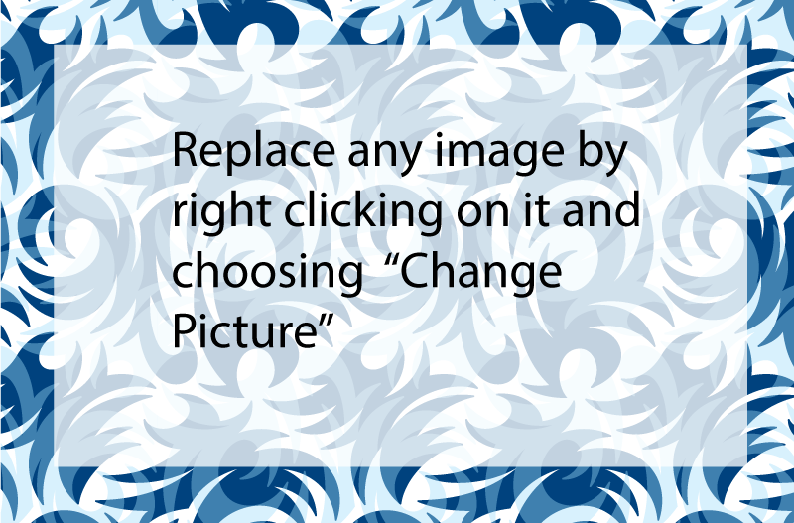

**Your Company Name**

(Replace with your company logo)

**Capabilities Statement**

(1) Replace this with a short intro paragraph describing your business. (2) Use clear, concise, and substantiated statements. (3) Convey who you are without repeating your core competencies or differentiators word for word.

**Company Snapshot**

Established: 1996 (unless very recent)

CAGE: 1A2B3C

UEI: 0123456789

Do you accept credit/purchase cards?

List any contract vehicles – GSA schedules, CMAS, BPAs, etc.

Specify if you serve a geographic area

**NAICS Codes (or UNSPSCs)**

*[Include NAICs codes if for Federal agency and UNSPSCs for California agency]*

*[include description as well as code]*

236220 - Commercial and Institutional Building Construction

236210 - Industrial Building Construction

115310 – Support Activities for Forestry

**Licenses & Certifications:**

*(Can include cert logos here as well)*

CA SB #5555

WOSB

WBE, etc.

Contractors’ license #555, MCP, LTO, etc.

**Your Company(If it is not clearly in the logo)**

**Core Competencies**

* **Bulletized list** 
  + - of services that your company offers
    - List in priority order – significance
    - No narrative descriptions
    - Customize to focus on what the potential client needs
* **Separate topics as needed**
  + - Make this an easy at-a-glance list – not too long!
    - Not a sales pitch – save that for Differentiators
    - If using details . . .quantify and qualify whenever possible

**Differentiators**

What makes you different than the competition? Are your employees especially skillful? Why is your service/product better? Use data if possible & BE VERY CONCRETE AND BRIEF­.

**Experience**

**[Most Recent or Most Relevant Client] – [Period of performance]**  
List experience in order of similarity to the targeted audience (Federal, State, Local, etc.) Customize to focus on what the potential client. What did you do, how much were you paid?

**[Past or Next Most Relevant Client] – [May 2022-June 2024]**  
Include dollar value, performance period, or other aspects that provide examples of success. The goal is to reflect depth – lowering the potential client’s risk. Stay away from testimonials and references.

**[Past or Next Most Relevant Client] – [Summer 2021]**

If you don’t have government contracting experience, you can list private work experience. Anything commercial or corporate is best. You can get creative to adapt these sections – the idea is to impress.

**Contact**

Your Name, Your Title

Email: name@company.com

*[don’t use generic “sales/info” address]*

Phone: 111-222-3333

Fax: 333-222-1111

Address: 123 Your Street, City, CA 98765

*Visit Our Website:* [*www.company.com*](http://www.company.com)



______________________________________________________________________________________________________________________

**111-222-3333 | 123 Your Street, City, CA 98765 |** [**www.company.com**](http://www.company.com) **(This text box is anchored to text above)**

(Use white background logos where possible)

**Key Clients**